Contents

1. Representing Ohm’s law and verifying its VI characteristics. 2

Solution: 2

Output: 3

2. Generating Value of PI using Monte Carlo method and check its accuracy 4

Solution: 4

Output: 6

3. Implementing Various models in simulation like: 7

Cruise control system Mechanical system 7

Solution: 7

Output 8

4. Implementing GPSS programs 9

Solution: 9

Output: 9

Solution:(Code) 10

Output: (Screenshot) 10

# Representing Ohm’s law and verifying its VI characteristics.

## Solution:

### Objectives:

1. Create a Simulink model to represent Ohm's Law.
2. Verify its characteristics:
   1. Current increases with voltage if resistance is constant.
   2. Current decreases as resistance increases, keeping voltage constant.

### Components Needed:

1. DC Voltage Source



1. Series RLC Branch



1. Current measurement

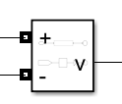

1. Voltage Measurement

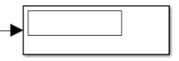

1. Display



1. Powergui

### Steps:

1. Setup the circuit
   1. Open MATLAB 🡪 Simulink 🡪 Create new model
   2. Drag and Drop the Components needed from library.
      * For Resistor search RLC Branch and double click on it, change branch type to **R** to make RLC to Resistor.
2. Connect Sensors to Scope
   1. Connect Voltage Sensor output and Current Sensor output
3. Simulation Parameters
   1. Set simulation time (10 seconds)
   2. Double click on the block and change different values for blocks
      * Change values for voltage and resistance according to requirement

## Output:

1. Vary Voltage, keeping Resistance Constant
2. Vary Resistance, keeping Voltage Constant

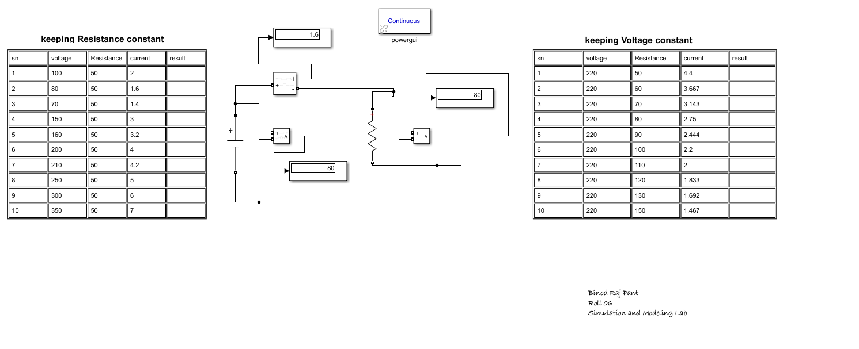

# Generating Value of PI using Monte Carlo method and check its accuracy

## Solution:

We will be using MATLAB for this experiment.

### Objectives:

1. Estimate the values of Pi using Monte Carlo method
2. Check its accuracy with comparison to actual value of pi
   1. By varying the no. of points to be drawn.

### Theory:

We make use of random sampling for generating the value of Pi. To estimate the value of Pi:

1. Consider a unit square with a quarter circle of radius 1 inside it.
2. Consider area of square is 1.
3. The area of quarter circle is pi/4.

### Tool used:

1. MATLAB

### Algorithm:

* + 1. Set the total number of random points n.
    2. Initialize a counter count_inside to zero.
    3. For each of n iterations:
       - 1. Generate random x and y between 0 and 1.
         2. If x2+y2 ≤1, increment count_inside.

1. Estimate π as:

𝜋 ≈ 4 x (count_inside)/n

1. Calculate percentage error using:

Error = ∣𝜋estimated – 𝜋actual| X 100

𝜋actual

### Code:

% Monte Carlo estimation of PI in MATLAB.

clc;

clear;

n = 1e6;  % Total number of points, you need to vary this number for wach experiment.

count_inside = 0;

% Generate random points using rand function

x = rand(1, n);

y = rand(1, n);

% to check how many points fall inside the quarter circle

distance_squared = x.^2 + y.^2;

count_inside = sum(distance_squared <= 1);

% Estimate PI

pi_estimated = 4 * (count_inside / n);

pi_actual = pi;

error_percent = abs((pi_estimated - pi_actual) / pi_actual) * 100;

% Display results

fprintf(“Total no of Random numbers = %d\n', n);

fprintf('Total no of random no inside circle = %d\n', count_inside);

fprintf('Estimated value of PI = %.6f\n', pi_estimated);

fprintf('Actual value of PI    = %.6f\n', pi_actual);

fprintf('Error Percentage      = %.6f%%\n', error_percent);

## Output:

**Name: Binod Raj Pant**

|  |  |  |  |  |  |
| --- | --- | --- | --- | --- | --- |
| **S .N** | **Total no of Points** | **No of points inside circle** | **Estimated value of PI** | **Actual value of PI** | **Error Percentage** |
|  | 100 | 81 | 3.240000 | 3.141593 | 3.132403% |
|  | 400 | 324 | 3.240000 | 3.141593 | 3.132403% |
|  | 500 | 387 | 3.096000 | 3.141593 | 1.451259% |
|  | 1000 | 766 | 3.064000 | 3.141593 | 2.469851% |
|  | 1e5 | 78555 | 3.142200 | 3.141593 | 0.019332% |
|  | 40000 | 31321 | 3.132100 | 3.141593 | 0.302161% |
|  | 20000 | 15811 | 3.141593 | 3.141593 | 0.655952% |
|  | 90900 | 71337 | 3.139142 | 3.141593 | 0.078009% |
|  | 1e6 | 785257 | 3.141028 | 3.141593 | 0.017973% |
|  | 1e7 | 7855480 | 3.142192 | 3.141593 | 0.019078% |

# Implementing Various models in simulation like:

## Cruise control system Mechanical system

## Solution:

### Objective:

To design a control system that maintains car’s speed by adjusting throttle input based on actual speed.

* Assumption:
  + Car moving on flat surface with zero slope
  + Drag force calculated using stroke’s law fd proportion to v

### Mathematical representation

N = mg //Normal force and mg cancels out each other

Fe – Fd = ma // resulting force in forward direction

Fe prop throttle prop input // throttle allows air flow in engine, and fuel combustion is determined to produce force and input is error signal generated when speed and set points are assigned.

Fe prop to input.k1 prop to input so we add k1 constant

Fd = k2 v // drag force prop to velocity of vehicle and k2 is constant

Replacing above in IInd equation: k1.(input) -k2v = ma

We know that acceleration is dv/dt so

The dynamics of car can be modeled by using the following first-order differential equation:

dv/dt=k2 v / m + k1 .input / m

### Model’s parameters:

Mass(m) = 1000kg

K1 = 50

K2 = 100

### Components:

1. Integrator
2. Sum block
3. Gain block
4. Scope
5. PID
6. Constant
7. Signal builder

## lab 3 iiOutput

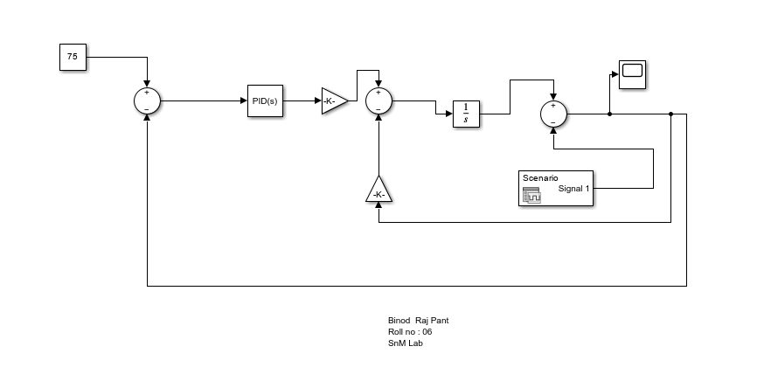

# 4.Implementing GPSS programs

1. Customers are arriving at the rate of 12 per minutes with the variance of 6 minutes. Consider there is only one barber at the shop and is serving customer at the rate of 15 per minutes with the variance of 3 minutes. Gather statistics for 500 customers.

## Solution:

Code:

QUEUE SEAT  
SEIZE BARBER  
DEPART SEAT  
ADVANCE 15,3  
RELEASE BARBER  
TERMINATE 1  
  
START 500

## Output:

Screenshot:

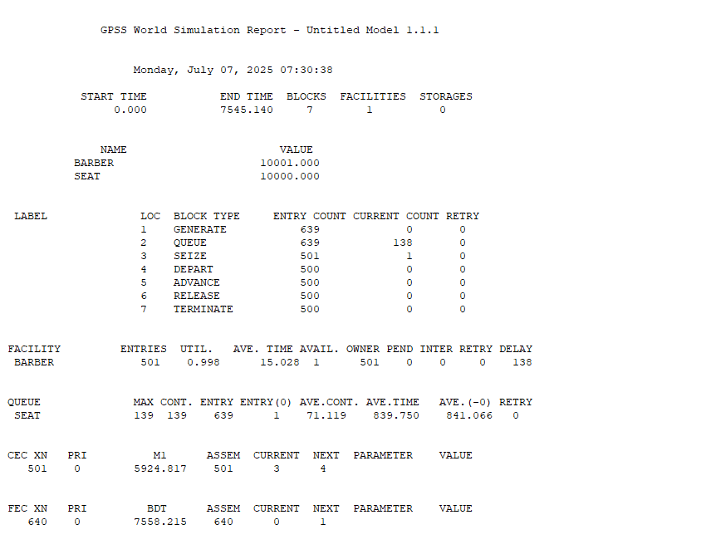

1. CG group is manufacturing refrigerator in a site and after assembly they are checked for verification. There is an inspector that verifies refrigerator and takes 25 minutes to verify with the variance of 5 minutes. Refrigerators are being transported through the conveyer belt and it takes 20 minutes to reach to inspector, consider 10 % of the refrigerators are marked defective and hence rejected. Gather statistics for 500 refrigerators.

## Solution:(Code)

GENERATE 20,0  
;QUEUE COVERYER  
SEIZE INSP  
;DEPART REF  
ADVANCE 25,5  
RELEASE INSP  
TRANSFER 0.1,ACC,REJ  
ACC TERMINATE 1  
REJ TERMINATE 1  
  
START 500

## Output: (Screenshot)

